**Spreadsheet**

**Class Six**

**Lab 22**

|  |
| --- |
| Lab Objectives:  * Inserting Data |

# The Google Sheet editing window

## This is what your blank Google Sheet will look like:

## IMG_256

## You can rename your Sheet in the top left corner. Click on where it says Untitled spreadsheet and type in whatever name you want to give your Sheet, in this example “New Sheet”.

## So let’s introduce some key terminology and the fundamental concept upon which spreadsheets work:

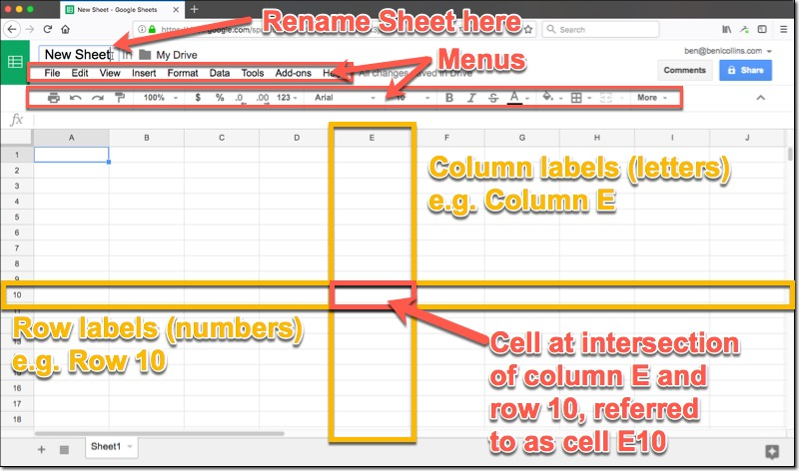

## There are two menu rows above your Sheet, of which we’ll see more further on in this tutorial.

## The main window consists of a grid of cells. An individual cell is a single rectangle, at the intersection of one column and one row, and it’ll hold a single piece of data.

## The columns are vertical ranges of cells, labeled by letters running across the top of the Sheet.

## Rows are horizontal ranges of cells, labeled by numbers running down the left side of your Sheet.

## In the example above, We highlighted column E and row 10.

# The fundamental concept of spreadsheets

## Column E and row 10 intersect at one cell, and one cell only. Thus we can combine the column letter and row number to create a unique reference to this cell, E10. Now when we want to refer to this cell, for example to access data in this cell, we use the address E10 to do that.

## Understand this and you understand spreadsheets. The rest is just details!

## Entering, selecting, deleting and moving data

## Now the fun really starts! Let’s start using this new blank sheet we’ve created.

## Click cell A1 (that’s the intersection of column A with row 1, the cell in the top left corner of the Sheet) and you’ll see a blue box around the cell, to indicate it’s highlighted:

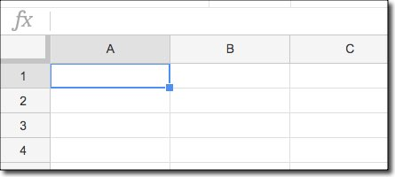

## Then you can simply start typing and you’ll see the data being entered into that cell:

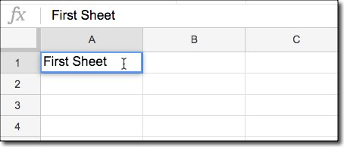

## Hit enter when you’ve finished entering data and you’ll move down to the next cell, having completed your data entry. If you hit the Tab key instead, you’ll move across one cell to the right!

## It’s worth pointing out an important nuance here:

## Clicking **ONCE** on the cell highlights the whole cell. Clicking **TWICE** enters into the cell, so you can select or work with the data only.

## If you find yourself stuck inside a cell, you can press the **ESCAPE** key to deselect the contents and go up a level, to just having the cell selected.

## Try it for yourself and see how the cursor shows up inside the cell when you double-click, allowing you to edit the data.

## You can also undo using the Undo arrow on the menu:

## IMG_260

# Creating a basic table

## Right, with all that in mind, it’s time for a quick exercise.

## See if you can create the following table for our fictitious gym membership site, by entering the data into the correct cells :

## IMG_256

## Feel free to use your own data if you wish.